Express and Mongo Tutorial

<https://zellwk.com/blog/crud-express-mongodb/>

Building a Simple CRUD Application with Express and MongoDB

## **CRUD, Express and MongoDB**

CRUD, Express and MongoDB are big words for a person who has never touched any server-side programming in their life. Let’s quickly introduce what they are before we diving into the tutorial.

[**Express**](https://expressjs.com/) is a framework for building web applications on top of Node.js. It simplifies the server creation process that is already available in Node. In case you were wondering, Node allows you to use JavaScript as your server-side language.

[**MongoDB**](https://www.mongodb.com/) is a database. This is the place where you store information for your web websites (or applications).

[**CRUD**](https://en.wikipedia.org/wiki/Create,_read,_update_and_delete) is an acronym for Create, Read, Update and Delete. It is a set of operations we get servers to execute (POST, GET, PUT and DELETE respectively). This is what each operation does:

* **Create (POST)** - Make something
* **Read (GET)**_- Get something
* **Update (PUT)** - Change something
* **Delete (DELETE)**- Remove something

If we put CRUD, Express and MongoDB together into a single diagram, this is what it would look like:

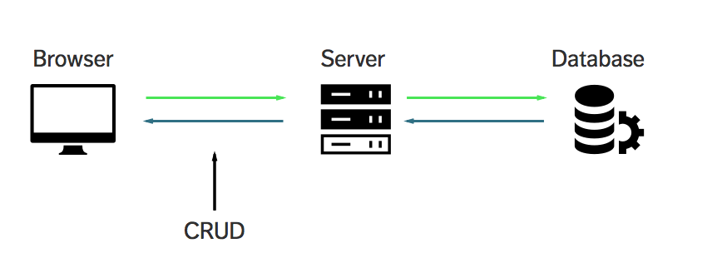

Does CRUD, Express and MongoDB makes more sense to you now?